Experiment 4

:Momentum and Impulse

Name: Jonathan Goh

UID: 404901382

Date Performed: 5/9/18

Lab Section: Wednesday 8 a.m.

TA: She, Zhenyu

Partner: Daniel Schwartz

**Worksheet:**

1. Discussion
   1. Measured Values
      1. Mass of the Glider:

* + 1. Width of Photogate Flag: $3.8±0.05 centimeters$
  1. Plot and Table of Calibration of Force Sensor
     1. Calibration Constant: $-6.285±0.022 newton/volt$

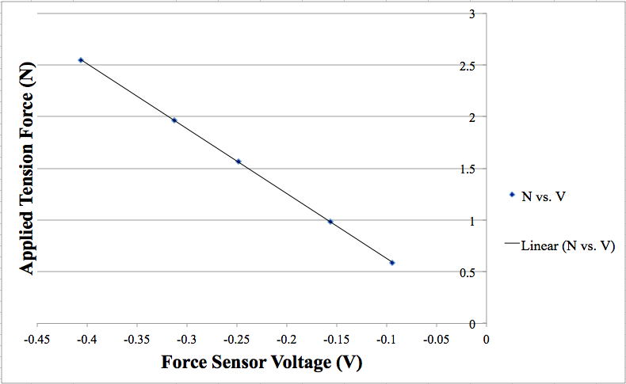

**Figure 4.1 Calibration of the Force Sensor**. The force sensor voltage and applied tension force were plotted to calculate the calibration force of the sensor. The equation of the line of best fit was $y=-6.2805x-0.0008$. The coefficient of $x$ (the slope of the line of best fit) is the calibration constant; therefore, $-6.285±0.022 newton/volt$ is the calibration constant.

* 1. Impulse Calculation: Given by the Photogate Calculated Velocity

|  |  |
| --- | --- |
| **Trial 1** | **Velocity (m/s)** |
| Velocity 1 ($v{}_{i}$) | $-0.37535±0.000005$ |
| Velocity 2 ($v{}_{f}$) | $0.14281±0.000005$ |

**Figure 4.2** Table of velocities recorded by the photogate for trial 1. The negative denotes that the glider was traveling towards the force sensor and vice-versa.

|  |  |
| --- | --- |
| **Trial 2** | **Velocity (m/s)** |
| Velocity 1 ($v{}_{i}$) | $-0.42096±0.000005$ |
| Velocity 2 ($v{}_{f}$) | $0.12879±0.000005$ |

**Figure 4.3** Table of velocities recorded by the photogate for trial 2. The negative denotes that the glider was traveling towards the force sensor and vice-versa.

Calculations

Given that:

Mass of Glider, $m=0.202±0.00005 kilograms$

Momentum, $P=mv$

Impulse, $J=ΔP=P{}_{f}-P{}_{i}=m(v{}_{f}-v{}_{i})$

Substitute Values From **Figure 4.2** and **Figure 4.3**:

$ΔP{}_{Trial 1}=0.202±0.00005 [ (0.14281±0.000005)-(-0.37535±0.000005) ]$

$ΔP{}_{Trial 2}=0.202±0.00005 [ (0.12879±0.000005)-(-0.42096±0.000005) ]$

Final Values:

* 1. Impulse Calculation: By Using Integration

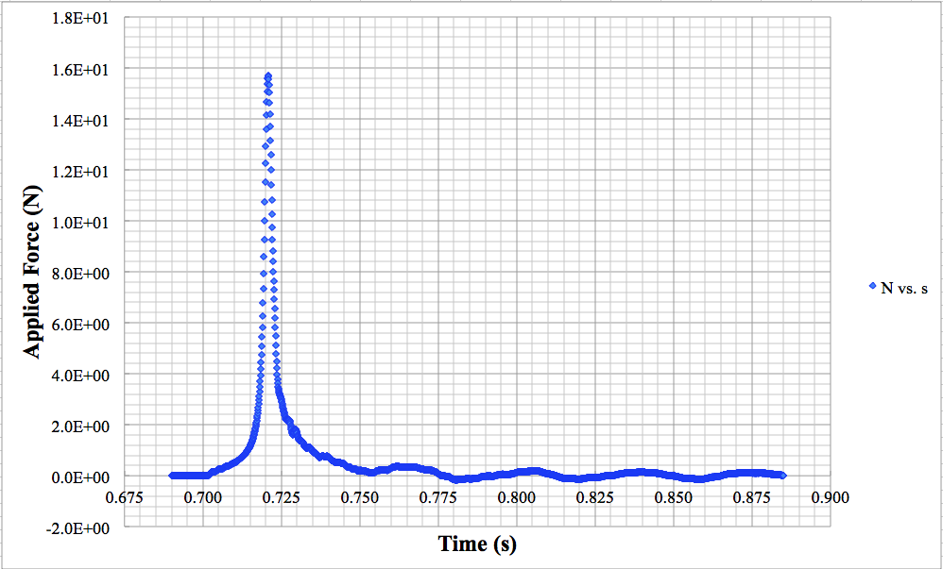

**Figure 4.4 Trial 1 Plot of Sensor Readings Over Time.** Since the calibration constant is in units of N/V we can simply multiply the calibration constant by the Voltage (V) that the force sensor recorded in order to find the Force (N) at any given Time (t). Each point represents the converted force sensor readings. The area under the curve is representative of the impulse of the function. Slight ringing can be seen after the collision but these oscillations are negligible.

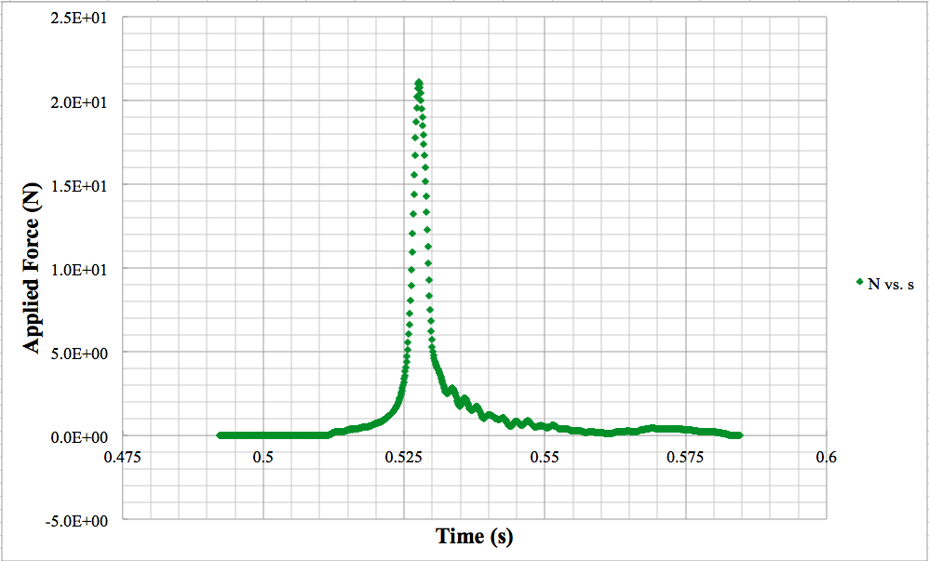

**Figure 4.5 Trial 2 Plot of Sensor Readings Over Time.** Since the calibration constant is in units of N/V we can simply multiply the calibration constant by the Voltage (V) that the force sensor recorded in order to find the Force (N) at any given Time (t). Each point represents the converted force sensor readings. The area under the curve is representative of the impulse of the function. Slight ringing can be seen after the collision but these oscillations are negligible.

Calculations

Given that:

Impulse, $J=ΔP=\int{}F(t)dt$

More specifically, we will use a Riemann Sum to calculate the integral:

$ΔP=\int_{t{}_{1}}^{t{}_{n}}{}F(t)dt ≈Δt\sum_{i=1}^{n}{}F(t{}_{i})$

For Trial 1:

The time range used to calculate the integral was from 0.700s - 0.7521s

$Δt=t{}_{i+1}-t{}_{i}=0.0001$

Sum of force measurements of peak $\sum_{i=1}^{n}{}F(t{}_{i})=949.5$

$ΔP{}_{Trial 1}=0.0001⋅1007.2097=0.1007 Ns$

For Trial 2:

The time range used to calculate the integral was from 0.5103s - 0.5630s

$Δt=t{}_{i+1}-t{}_{i}=0.6902-0.6901=0.0001$

Sum of force measurements of peak $\sum_{i=1}^{n}{}F(t{}_{i})=1079.934$

$ΔP{}_{Trial 2}=0.0001⋅1085.182=0.1085 Ns$

Calculating Uncertainties:

Using the fractional uncertainty of force sensor calibration coefficient.

Calibration Constant $= -6.285±0.022 newton/volt$

$\frac{δP}{P{}_{best}}=\frac{δk}{k{}_{best}}=\frac{0.022}{6.285}=0.004$

Trial 1-

$δP=0.004⋅P{}_{best}$

$δP=0.004⋅0.1007=0.0004$

Trial 2-

* 1. Calculated Impulse Values For Each Method

|  |  |
| --- | --- |
| **Method 1** | **Calculated Impulse** |
| Trial 1 | $ΔP{}_{Trial 1}= 0.10467±0.00003 Ns$ |
| Trial 2 | $ΔP{}_{Trial 2}= 0.11105±0.00003 Ns$ |
| **Method 2** | **Calculated Impulse** |
| Trial 1 | $ΔP{}_{Trial 1}=0.1007±0.0004 Ns$ |
| Trial 2 | $ΔP{}_{Trial 2}=0.1085±0.0004 Ns$ |

**Figure 4.6 Table of Calculated Impulse Values.** When the percent difference is calculated between the two calculation methods, a percent difference of 3.7928% for Trial 1 and a percent difference of 2.2963% for Trial 2. Granted that there is some margin of error, the two methods of calculating impulse are pretty much equal.

**Presentation Mini-Report**

Introduction:

Impulse is known as the net force that is acting upon an object over a period of time and is a directional, vector, quantity. The standard unit of measure for impulse is the SI unit, newton seconds ($Ns$); and impulse can, in fact, be derived from Newton’s Second Law of Motion. Impulse can be defined as either the change in momentum from time $t{}_{1}$ to $t{}_{2}$, commonly known as the impulse momentum theorem, or can be defined as the integration of the net force from time $t{}_{1}$ to $t{}_{2}$. The purpose of this experiment was to ensure that both of the defined methods for calculating impulse were applied correctly, and that both calculation methods resulted in the same answer. To set up this experiment, a glider with a flag attached to the top was set on an airtrack. A photogate was used to collect the raw data about the glider’s collision with the force sensor at the end of the track. The first method of calculating impulse used the photogate recorded values of velocity before and after the collision to measure change in momentum over time. The second method of calculating impulse used a plot of the readings from the force sensor at the time the glider made impact. Using the plot of force, a riemann sum was used to calculate the impulse by taking the integral of force over the respective time interval. Lastly, the values of impulse were compared to verify that both calculations of impulse were completed correctly.

Word Count: 253

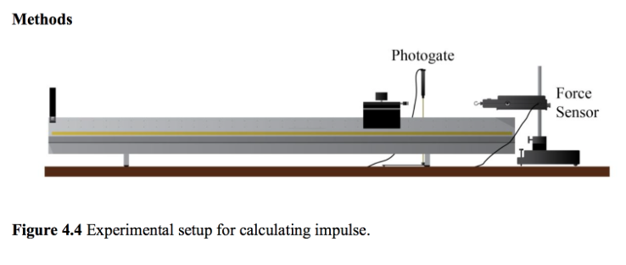

**Figure 4.7 Apparatus used to collect data for impulse calculations.**

Methods:

Before collecting the data to calculate the values of impulse, the force sensor needs to be calibrated. In order to properly calibrate the force sensor, the sensor must be hung from a metal clamp, pointed downward, so that the hook is facing towards the ground and a series of five different masses (i.e. 60g, 100g, 160g, 200g, and 260g) are attached to the hook. Record the voltages from the “User Defined Sensor” outputs of the force sensor for each mass onto a spreadsheet, and convert the values of mass to tension force by multiplying the masses by the acceleration due to gravity ($9.8 m/s^{2}$). Using the tension forces and the masses, plot the data sets onto a scatterplot and generate a line of best fit for the data points. Using the equation of the line of best fit, the coefficient of x (the slope of the line) can be used as the calibration constant, which is important for a later step in the experiment.

Next, the apparatus depicted in **Figure 4.8** must be setup. Essentially, a glider must be put on top of an airtrack; on the end of the track, the force sensor must be setup so that the bumper on the glider has direct contact with the hook on the force sensor; and the photogate sensor should be placed anywhere along the airtrack as long as it can read the starting and ending velocities of the glider. Measure the mass of the glider with the flag and bumper(s) attached, and measure the the length of the flag; record the data.

After the apparatus was built, the force sensor and photogate were connected to the DAQ and a predefined timer was selected for the photogate. When prompted to enter the Speed field, input the length of the glider flag; the program automatically computes the length divided by time to get the speed. For the force sensor, the same “User Defined Sensor” voltage output should be used, and the sample rate should be set to $≤10 kHz$. Create a table with columns for Time (s), User Defined (V), and Speed (m/s); once the record button is hit, all data should be recorded in continuous mode.

Data collection is straightforward. When the record button is pressed, gently push the glider past the photogate, towards the force sensor. After the glider has returned past the photogate for the second time, stop recording. There should be full rows of data for Time (s) and User Defined Sensor (V), while Speed (m/s) should only have values for the velocity at the start and at the end. Repeat this step for a second trial.

Several precautions were taken in order to avoid systematic errors in the experiment. Firstly, any background force was subtracted from the plots and data sets, this was helpful because it disregarded extra area under the curve of the force vs. time plot. Extra area due to background force would have skewed the end calculation of of impulse using methodology 2 (integration of force vs. time). Secondly, the airtrack was not only level, but also had minimal friction due to the air flow along the track. Without the airflow, friction would have caused a lot of systematic errors.

**Bibliography:**

1. Campbell, W. C. et al. Physics 4AL: Mechanics Lab Manual (ver. August 31, 2017). (Univ. California Los Angeles, Los Angeles, California).
2. Young, Hugh D, Roger A. Freedman, A L. Ford, and Francis W. Sears. Sears and Zemansky's University Physics: With Modern Physics. San Francisco: Pearson Addison Wesley, 2004. Print.